City of Glenwood

Sign Permit Application

Submit signed applications and all attachments to:  City of Glenwood, PO Box 254, Glenwood, MN 56334. | Office use only
 | Permit Number | Date rec’d
Property
Property address

Type of building:
Single Tenant
Multiple Tenant
Zoning District:
General property information Contact Planning Division if unknown.

Purpose: New Sign Replacement Sign
Face Change (No Frame/Support Change)

Special use signs: Gasoline/Service Station O Hotel: No. stories
No. rooms

Select all that apply. Historic/Information Retail School/Hospital/Governments

Bars/Restaurants Billboards Information (Time/Temperature/Etc.)
Menu boards Residential Units Other:
Property owner/Legal representative Original signature required.

Name | E-mail
Address | City | State | Zip
Contact | Title | Phone
Signature (Original signature mandatory)  Business Owner/Representative/Tenant |  | Date

Business Name | E-mail
Address | City | State | Zip
Primary Contact | Phone | Other

Name | E-mail
Address | City | State | Zip
Contact | Phone | Other

I hereby apply for a sign permit and certify the information herein is complete and accurate; that the work will be in conformance with the ordinances and codes of the City of Glenwood; that I understand that this is not a permit but only an application for a permit and work will not start until the sign permit and all other applicable permits are issued and all work will be in accordance with the approved plan and permits. I further understand that failure to remain in compliance may result in revocation of my permit, orders to remove the sign(s), to bring the sign(s) into compliance, and/or other legal action.
Installer or Applicant, If Applicable

Applicant or Installer signature Check one. Date

City of Glenwood PH: 320-634-5433 EMAIL: COG@ci.glenwood.mn.us

Glenwood City Code: How to measure a sign

Sign surface area of individual cabinet or iconic logo sign
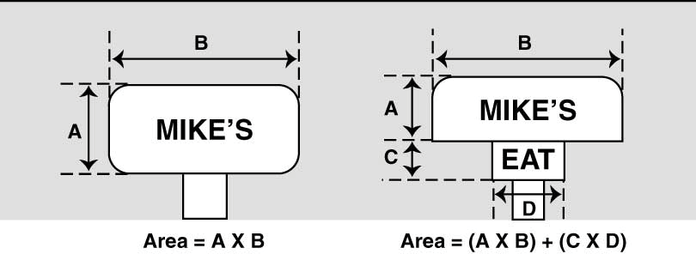
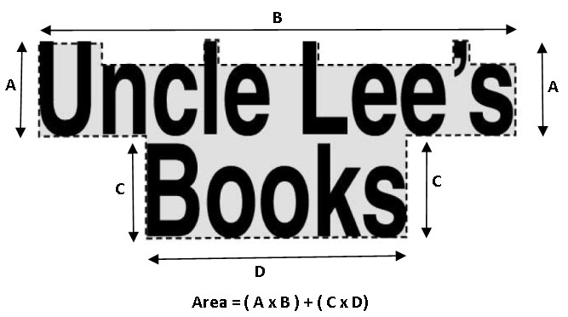
Sign surface area of individual letter signs, letters or symbols

Height of sign with grade mounting

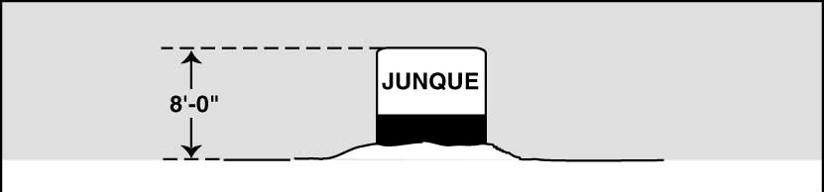

or less
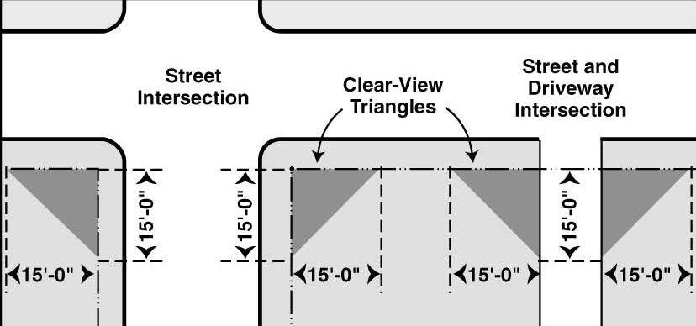
Clear view triangle area intersection of streets and driveways

NOTE: Permanent signs shall NOT have a combined aggregate surface size greater than three (3) sq feet for each linear foot of frontage as calculated below. Buildings with multiple frontages MUST calculate each frontage separately. Each frontage MUST be clearly labeled on the site plan(s).

Please complete ALL sections that apply:
- North Frontage:

South Frontage:

linear feet x 3 = Max Square Footage linear feet x 3 = Max Square Footage

East Frontage: D. West Frontage:

linear feet x 3 = Max Square Footage linear feet x 3 = Max Square Footage

E. Other Frontage (please explain):
Total Maximum Sign Area Permitted:
+
+
+
+
=
A B C D E Total

linear feet x 3 = Max Square Footage Existing Signage (if applicable) = Total Sq Feet

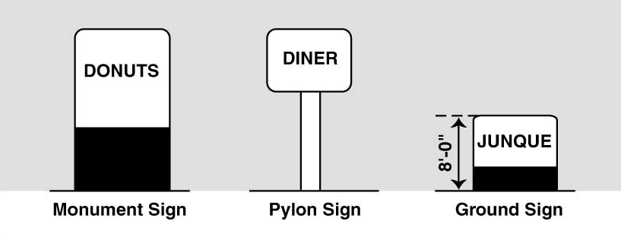
Sign Elevation:
Permanent Freestanding Identification Signs

Width ft. X Height (Max. 25 feet) ft. = Total sq.ft

Elevation type: Primary Secondary

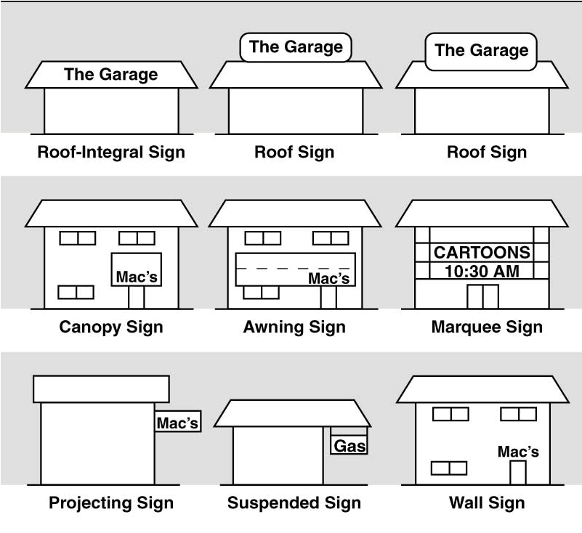
Sign Dimensions:
Permanent Wall & Building Signs
Width ft. X Height

ft.

= Total sq.ft

Permanent Wall & Building Signs
Building Elevation:
Width ft. X Height (Max. 25 feet) ft. = Total sq.ft

Elevation type: Primary Secondary

Sign Dimensions:
Width ft. X Height

ft.

= Total sq.ft

Dynamic/Illuminated Signs

Height above grade: ft.
Setbacks: Front: ft. Side: ft. Rear: _____ft.

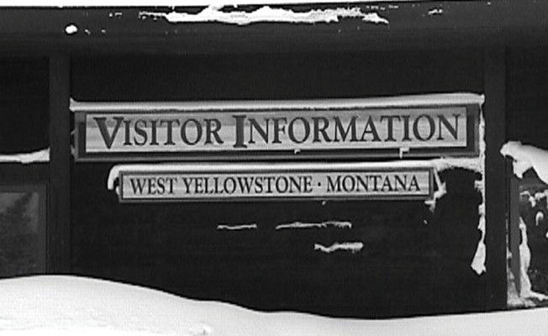
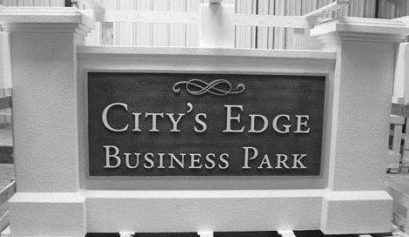
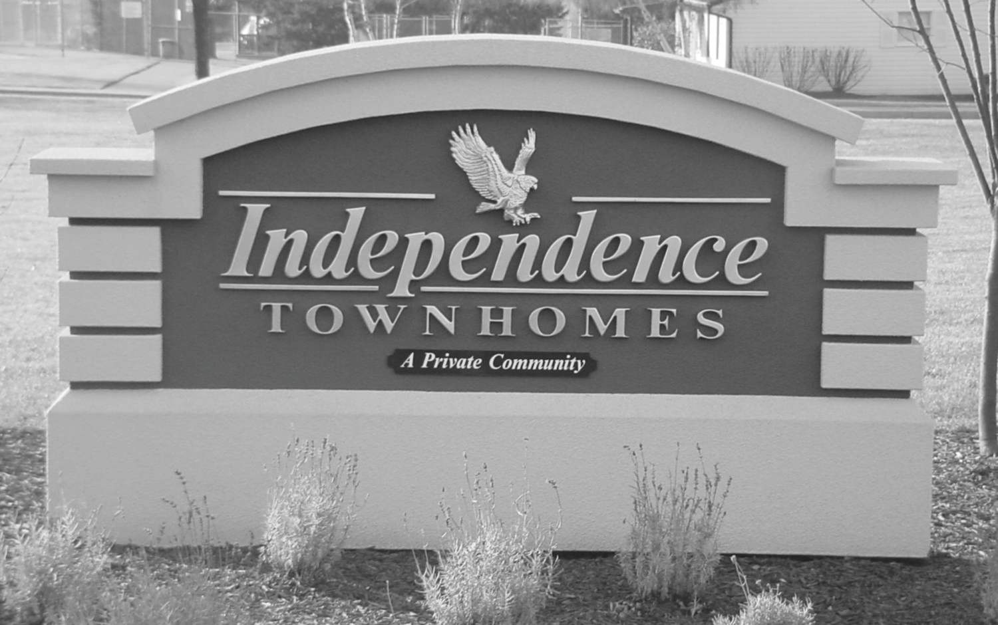
Illumination Yes No If yes, complete below
Informational/Business Park/Residential Unit Signs

Source/Brightness:
Type: Fluorescent Neon LED
Internal: Nits External: Lumens Other
Informational Sign Business Park Sign Residential Sign

Business Park/Residental Unit Sign

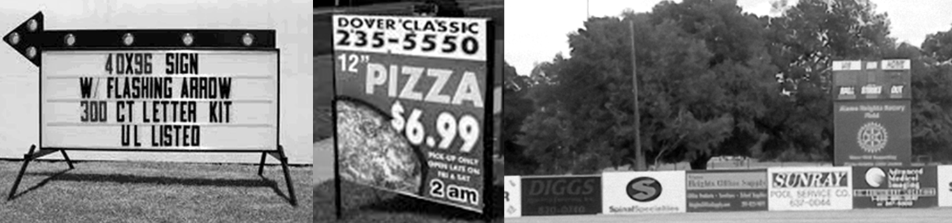
Temporary, Portable Signs

Duration: Text: Seconds
Images: Seconds
Sign Dimensions:
Width ft. X Height
Permit Fees (See Annual Fee Schedule set by the City Commission)

ft.

= Total sq.ft

Permanent Free Standing Identification Signs
Number of Signs x $ 250.00/sign = $
Permanent Wall & Building Signs
Number of Signs x $ 100.00/sign = $

Signs and/or Banners
NOTE: May be used up to two (2) weeks at a time, no more than four (4) times per year. Each use requires a separate permit and fee.
Informational/Business Park/Residential Unit Signs
Number of Signs x $ 75.00/sign = $ Temporary, Portable Signs

Start Date:
End Date:
Number of Signs x $ 25.00/sign = $

Total Permit Fees =

City of Glenwood Sign Application Process & Submittal Requirements:
- Complete all required information for each sign.
- Provide a site plan drawn to scale, including all other applicable information as required for each type of sign.
  - For Wall Signs:
    - The wall elevation drawn to scale.
iii. A drawing of each sign drawn to scale.
  - For Freestanding Signs:
ii. A graphic depiction of each sign, drawn to scale with the height dimensions included.
- Submit the required non-refundable permit application fee with all required application materials to:
City of Glenwood
PO Box 254
Glenwood, MN 56334
- If the sign application is deemed incomplete for any reason, the applicant shall be required
to submit additional information deemed appropriate and/or required by the City. In the event of resubmission for an incomplete application, the permit application fee may be waived at the discretion of the City of Glenwood.
- All signs which have electrical service shall require an electrical permit. All Freestanding signs shall require a foundation permit. Applicable fees and inspections shall apply.
- Once a sign permit application has been approved and fees paid, a sign permit shall be
issued. If the signature block indicates that an electrical or foundation permit is required, the sign
- Once the sign(s) is/are installed, the City of Glenwood will require electronic scans, photographs, or other similar copies to be submitted and kept on file.

NOTE: Do NOT fabricate, install, construct, and/or erect a sign until a sign permit has been issued. Failure to secure a sign permit and/or abide by the Glenwood City Code MAY result in removal of signs, revocation of existing permits, and/or other penalties as applicable at the discretion of the City of Glenwood.

The application has been reviewed for City Code compliance and the applicant may commence the installation. however, if the sign requires electrical service or a foundation, the sign may not be installed until the electrical permit or foundation permit is approved. (See Requirements for additional permits section below). | Permit Fees | $
 | Penalty | $
 | TOTAL | $
Signs may NOT be installed until all the required sign-related permits are issued.
Requirements for additional permits below:
Electrical Permit Required Not required
Contact: ________________
Foundation Permit Required Not required
Contact: ________________
No additional permits Sign may be installed.
Comments:

Signature: Date: , 20

