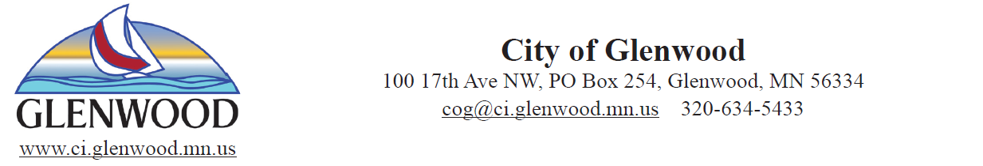

August 3rd, 2021

Dear Residents,

City of Glenwood residents are receiving this letter to notify water users of a consumption advisory regarding the municipal water supply. In addition, individual and business owners with properties that utilize private wells may also be affected.

The City of Glenwood, is dedicated to providing clean and safe drinking water to residents. Testing by the Minnesota Department of Health (MDH) shows the city’s municipal water supply continues to meet all Safe Drinking Water Act standards.

MDH conducted additional testing in early 2021 as part of a study of unregulated contaminants. The testing showed one of the city wells had manganese levels above MDH recommended health guidelines.

The problem: Manganese
Manganese is a natural occurring element found in rocks and soil and is often found in Minnesota ground and surface water. Our bodies need some manganese to stay healthy, but too much can be harmful. You can learn more by visiting the MDH webpage at www.health.state.mn.us and search for Manganese in Drinking Water.

Manganese is unregulated and does not have an enforceable standard. However, the MDH recommended health guidelines are:

- If you have an infant who drinks tap water or drinks formula made with tap water, a safe level of manganese in your water is 100 parts per billion (ppb) or less.
- If you have an infant who never drinks tap water or formula made with tap water, a safe level of manganese in your water is 300 ppb or less.
- If everyone is more than one year old, a safe level of manganese in your water is 300 ppb or less.
The Solution:
The city’s municipal water is a mixture of water from two different city wells. The water mixes in water main lines and water towers and then travels to the customer tap. The city is unaware of manganese levels at any given drinking water tap.
MDH has collected samples for manganese at both city wells. The results are shown below:

Well # 2/3/21 3/17/21 Average MN (ug/L)
5 ND ND ----------------------
6 474 499 486.5
**ug/L = micrograms per liter or ppb, ug/l = ppb
**ND = not detected above the method reporting limit.

The city is working with engineering and MDH to find solutions for removing or reducing the manganese levels in the water supply. We have found by mixing the water from both wells the levels are reduced significantly, in our test cases the levels were reduced to well below the 100 ppb recommended amount, also by softening your water or having an RO System the manganese levels are reduced significantly.

The city is utilizing well #5 as much as possible, but with the dry hot weather well #6 must be used to keep up to demand. We are evaluating the short-term, mid-term and long- term solutions. Solutions range from softening your water to drilling new wells to constructing treatment facilities to remove the manganese. Softening and/or using a RO System is the most reasonable way to remove the manganese in the water.

There are a few things that you can do as a user, filter the water with pour through type pitcher, install a faucet mounted filter, soften or use a RO System to treat your water. In other communities softening the water has removed some manganese.

We have taken samples from 11 different random sites within the city, some softened, some not, and one from a RO faucet. The only sites that were above 100 ppb, were well #6 and the Booster. This would indicate that the higher manganese comes from the well and is passed along to the Booster station, but once the water travels through the distribution system the manganese is reduced, possibly with mixing water from well #5. The results are listed below:

Hard Water Tap Softened Water RO System
#1 <10 ppb #6 <10 ppb
#2 50 ppb #7 <10 ppb #8 <10 ppb
#3 470 ppb(well6) #9 <10 ppb
#4 360 ppb(booster) #10 <10 ppb
#5 10 ppb #11 <10 ppb

This study shows a significant reduction in manganese from the softened and the RO System compared to the hard water tap, but the mixing of the water from each well also decreases the manganese levels to less parts per billion than the Health Advisory’s 100 ppb. The well and the booster show higher ppb, but do not mix as the water from customer’s homes does. The manganese levels from the sites that were sampled would indicate that the mixing of the water in the system from both wells is enough to decrease the manganese levels to below the Health Advisory of 100 ppb. Softening or the use of a RO system may also reduce the manganese levels.

This notice is only to make you aware of the manganese in the water, it is for your information only and the city plans to operate the water system as we have in the past, utilizing both wells and trying to create a mixing of the water to reduce the manganese. The city will keep its customers informed if there are any changes to the levels as we move into the future.

Please refer to the MDH webpage for information on manganese in drinking water at www.health.mn.us.
If you have questions on where to look for information, please call City Hall at 320-634-5433.

David Perryman
Public Works Director
City of Glenwood

